SUJAY J K  
1NT20IS171

**LAB PROGRAM - 1**

1. **Textview**
2. **Button**
3. **Imageview**
4. **Webview**
5. **Activity lifecycles**

**MainActivity.java**

**package com.example.NEW APP;**

**import androidx.appcompat.app.AppCompatActivity;**

**import android.os.Bundle;**

**import android.webkit.WebView;**

**import android.widget.Toast;**

**public class MainActivity extends AppCompatActivity {**

**@Override**

**protected void onCreate(Bundle savedInstanceState) {**

**super.onCreate(savedInstanceState);**

**setContentView(R.layout.*activity_main*);**

**Toast.*makeText*(this, "Activity created", Toast.*LENGTH_LONG*).show();**

**WebView wv = (WebView)findViewById(R.id.*webb*);**

**wv.loadUrl("https:www.google.com");**

**}**

**@Override**

**protected void onStart() {**

**super.onStart();**

**Toast.*makeText*(this, "ACTIVITY STARTED", Toast.*LENGTH_SHORT*).show();**

**}**

**@Override**

**protected void onPause() {**

**super.onPause();**

**Toast.*makeText*(this, "ACTIVITY PAUSED", Toast.*LENGTH_SHORT*).show();**

**}**

**@Override**

**protected void onResume() {**

**super.onResume();**

**Toast.*makeText*(this, "ACTIVITY RESUMED", Toast.*LENGTH_SHORT*).show();**

**}**

**@Override**

**protected void onStop() {**

**super.onStop();**

**Toast.*makeText*(this, "ACTIVITY STOPPED", Toast.*LENGTH_SHORT*).show();**

**}**

**@Override**

**protected void onDestroy() {**

**super.onDestroy();**

**Toast.*makeText*(this, "ACTIVITY DESTROYED", Toast.*LENGTH_LONG*).show();**

**}**

**}**

**Activity_main.xml**

**<?xml version="1.0" encoding="utf-8"?>**

**<androidx.constraintlayout.widget.ConstraintLayout xmlns:android="http://schemas.android.com/apk/res/android"**

**xmlns:app="http://schemas.android.com/apk/res-auto"**

**xmlns:tools="http://schemas.android.com/tools"**

**android:layout_width="match_parent"**

**android:layout_height="match_parent"**

**android:rotationX="2"**

**tools:context=".MainActivity">**

**<Button**

**android:id="@+id/button"**

**android:layout_width="wrap_content"**

**android:layout_height="wrap_content"**

**android:layout_marginStart="156dp"**

**android:layout_marginTop="16dp"**

**android:text="Button"**

**app:layout_constraintStart_toStartOf="parent"**

**app:layout_constraintTop_toTopOf="parent" />**

**<TextView**

**android:id="@+id/textView"**

**android:layout_width="wrap_content"**

**android:layout_height="wrap_content"**

**android:layout_marginStart="188dp"**

**android:layout_marginTop="136dp"**

**android:text="sujay"**

**app:layout_constraintStart_toStartOf="parent"**

**app:layout_constraintTop_toTopOf="parent" />**

**<ImageView**

**android:id="@+id/imageView2"**

**android:layout_width="wrap_content"**

**android:layout_height="wrap_content"**

**android:layout_marginStart="136dp"**

**android:layout_marginTop="361dp"**

**app:layout_constraintBottom_toBottomOf="parent"**

**app:layout_constraintEnd_toEndOf="parent"**

**app:layout_constraintHorizontal_bias="0.0"**

**app:layout_constraintStart_toStartOf="parent"**

**app:layout_constraintTop_toTopOf="parent"**

**app:layout_constraintVertical_bias="0.0"**

**app:srcCompat="@drawable/ade" />**

**<WebView**

**android:id="@+id/webb"**

**android:layout_width="409dp"**

**android:layout_height="99dp"**

**android:layout_marginStart="1dp"**

**android:layout_marginTop="1dp"**

**android:layout_marginEnd="1dp"**

**android:layout_marginBottom="1dp"**

**app:layout_constraintBottom_toTopOf="@+id/imageView2"**

**app:layout_constraintEnd_toEndOf="parent"**

**app:layout_constraintHorizontal_bias="0.0"**

**app:layout_constraintStart_toStartOf="parent"**

**app:layout_constraintTop_toBottomOf="@+id/textView"**

**app:layout_constraintVertical_bias="0.657" />**

**</androidx.constraintlayout.widget.ConstraintLayout>**

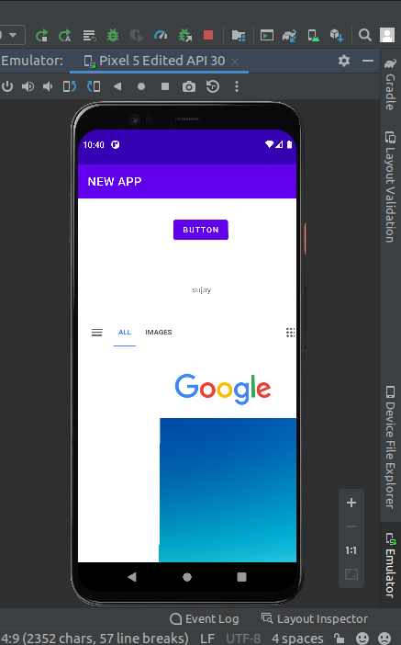

**5. LISTVIEW**

**MainActivity.java**

**package com.example.sujay_is171_prog1;**

**import androidx.appcompat.app.AppCompatActivity;**

**import android.os.Bundle;**

**import android.view.View;**

**import android.widget.AdapterView;**

**import android.widget.ArrayAdapter;**

**import android.widget.ListView;**

**import android.widget.Toast;**

**public class MainActivity extends AppCompatActivity {**

**@Override**

**protected void onCreate(Bundle savedInstanceState) {**

**super.onCreate(savedInstanceState);**

**setContentView(R.layout.*activity_main*);**

**ListView myList ;**

**String countryList[] ;**

**myList = findViewById(R.id.*list*) ;**

**countryList = getResources().getStringArray(R.array.*country*) ;**

**ArrayAdapter<String> arrayAdapter = new ArrayAdapter<String>(this,**

**R.layout.*support_simple_spinner_dropdown_item*, countryList);**

**myList.setAdapter(arrayAdapter);**

**myList.setOnItemClickListener(new AdapterView.OnItemClickListener() {**

**@Override**

**public void onItemClick(AdapterView<?> parent, View view, int position, long l) {**

**Toast.*makeText*(MainActivity.this, "You have clicked "+parent.getItemAtPosition(position), Toast.*LENGTH_SHORT*).show();**

**}**

**});**

**}**

**}**

**Activity_main.xml**

**<?xml version="1.0" encoding="utf-8"?>**

**<androidx.constraintlayout.widget.ConstraintLayout xmlns:android="http://schemas.android.com/apk/res/android"**

**xmlns:app="http://schemas.android.com/apk/res-auto"**

**xmlns:tools="http://schemas.android.com/tools"**

**android:layout_width="match_parent"**

**android:layout_height="match_parent"**

**tools:context=".MainActivity">**

**<TextView**

**android:id="@+id/textView"**

**android:layout_width="wrap_content"**

**android:layout_height="wrap_content"**

**android:layout_marginTop="486dp"**

**android:layout_marginEnd="91dp"**

**android:layout_marginBottom="38dp"**

**android:text="Hello World!"**

**app:layout_constraintBottom_toTopOf="@+id/list"**

**app:layout_constraintEnd_toStartOf="@+id/list"**

**app:layout_constraintStart_toStartOf="parent"**

**app:layout_constraintTop_toTopOf="parent" />**

**<ListView**

**android:id="@+id/list"**

**android:layout_width="match_parent"**

**android:layout_height="wrap_content"**

**app:layout_constraintBottom_toBottomOf="parent"**

**app:layout_constraintEnd_toEndOf="parent"**

**app:layout_constraintStart_toStartOf="parent"**

**app:layout_constraintTop_toTopOf="parent" />**

**</androidx.constraintlayout.widget.ConstraintLayout>**

